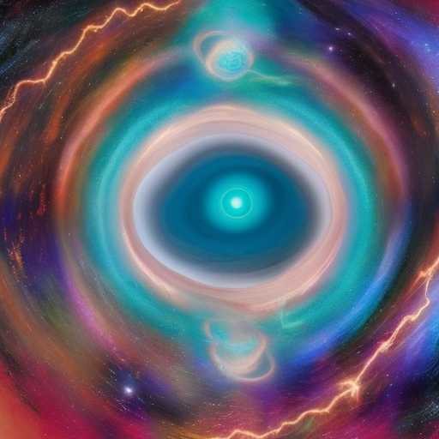
JUPITER OVER SATURN v.2

A transcendent mind stands outside of time, like Jupiter over Saturn

A transcendent mind tastes eternity and
comes back to earth in a flash to do the Supreme Activity

His Truth meets Her Wisdom as though an ever-
present in ux of turquoise lightning, that is somehow also stillness and ecstasy

The soul traveler goes willingly
into his passion, with that Divine Optimism that can only be drawn from the Sparks of Atziluth and the Holy
Waters of בְּרִיאָה

